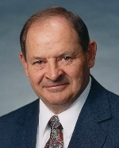
Sen. Gary Dahms
*2111 Minnesota Senate Bldg. (651) 296-8138
St. Paul, MN 55155

P.O. Box 158 (507) 641-5269
Redwood Falls, MN 56283
sen.gary.dahms@senate.mn
Sen. Kari Dziedzic
*2203 Minnesota Senate Bldg. (651) 296-7809
St. Paul, MN 55155

514 3rd Avenue NE (612) 623-7758
Minneapolis, MN 55413
sen.kari.dziedzic@senate.mn
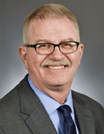
Rep. Rob Ecklund
*409 State Office Building (651) 296-2190
St. Paul, MN 55155

4647 Highway 11 (218) 341-6133
International Falls, MN 56649
rep.rob.ecklund@house.mn
William Faber– Gov. Appt.
7427 Cottonwood Road (218) 575-2328 (h)
Cushing, MN 56443 (218) 855-8082 (w)

Term ends – 01/01/2022
Appointed by Governor on 12/20/2017
wfaber@clcmn.edu
**Nancy Gibson – Co-Chair – Gov. Appt.
2712 Glenhurst Ave (952) 927-5512 (h)
St. Louis Park, MN 55416 (612) 747-3661 (w)

Term ends – 01/06/2020
Appointed by Governor on 6/18/2016
nangibson@comcast.net
Rep. Rick Hansen – Co-Chair
*407 State Office Building (651) 296-6828
St. Paul, MN 55155

1007 – 15th Ave. N.
South St. Paul, MN 55075
rep.rick.hansen@house.mn
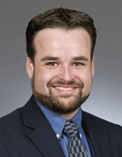
Rep. Josh Heintzeman
*353 State Office Building (651) 296-4333
St. Paul, MN 55155

P.O. Box 2723 (218) 820-5674
Baxter, MN 56425
rep.josh.heintzeman@house.mn
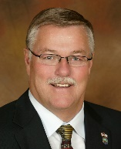
Sen. Bill Ingebrigtsen – Co-Chair
*3207 Minnesota Senate Bldg. (651) 297-8063
St. Paul, MN 55155

6968 Sunset Strip NW (320) 846-1893
Alexandria, MN 56308
sen.bill.ingebrigtsen@senate.mn
Nicole Kessler – Gov. Appt.
8262 Jonquil Ln N (612) 710-3358
Maple Grove, MN 55369

Term ends – 12/31/2020
Appointed by Governor on 01/27/2017
kessler.lccmr@gmail.com

Denny McNamara – House Appt.
1368 Featherstone Court (612) 366-7541
Hastings, MN 55033

Term ends – 12/31/2021
Appointed by the House on 05/2/2018
dennymcnamara7541@gmail.com
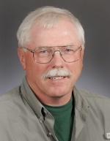
Norman Moody – Gov. Appt.
P.O. Box 396 (218) 536-1018
Hackensack, MN 56452

Term ends – 12/31/2020
Appointed by the Governor on 01/27/2017
snmoody@tds.net
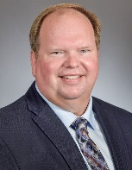
Michael Reese
26566 – 375th Ave (320) 589-1711
Hancock, MN 56244

Term ends – 12/31/2021
Appointed by the Senate on 5/24/2018
reesem@umn.edu

Rep. Tama Theis – Co-Vice Chair
*201 State Office Building (651) 296-6316
St. Paul, MN 55155

St. Cloud, MN 56302
rep.tama.theis@house.mn

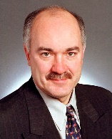
Sen. David Tomassoni – Co-Vice Chair
*2235 Minnesota Senate Bldg. (651) 296-8017
St. Paul, MN 55155

412 NW 2nd Street (218) 254-3430
Chisholm, MN 55719
sen.david.tomassoni@senate.mn
Rep. Jean Wagenius
*449 State Office Building (651) 296-4200
St. Paul, MN 55155

4804 - 11th Ave. S. (612) 822-3347
Minneapolis, MN 55417
rep.jean.wagenius@house.mn
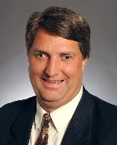
Sen. Torrey Westrom
*3201 Minnesota Senate Bldg. (651) 296-3826
St. Paul, MN 55155

P.O. Box 210 (218) 685-6299
Elbow Lake, MN 56531
sen.torrey.westrom@senate.mn
Della Young – Co-Vice Chair – Gov. Appt.
4309 Edinbrook Terrace N (651) 249-6974
Brooklyn Park, MN 55443

Term ends – 01/01/2022
Appointed by Governor on 12/20/2017
della@youngecg.com

* Address for preferred interim mail address
** Executive Committee Members

